UNIVERSITY OF BARISHAL

DEPARTMENT OF COMPUTER SCIENCE & ENGINEERING

Lab Final Report

Artificial Intelligence Lab
Course Code: CSE-3206

Submitted by:

SOURAV DEBNATH

22 CSE 009

Submitted to:

Dr. Tania Islam

Assistant Professor, Dept. of Computer Science and Engineering

Submission Date:

8July 2026

Project Overview
This report documents the HealthPlus Hospital Heart Disease Prediction project on a task-by-task basis, following the exact structure of the accompanying Google Colab notebook (HealthPlus_Heart_Disease_Prediction.ipynb). For every task, this report states the AI prompt that was used to generate or guide that section of the notebook, followed by the methodology, the actual results produced when the notebook was executed, and an interpretation of what those results mean for HealthPlus.
Dataset: heart.csv, containing 1025 patient records and 13 clinical features plus a binary target (1 = heart disease present, 0 = absent). All figures, tables, and numbers quoted below are taken directly from the executed notebook outputs estimated or assumed.

Task 1 Dataset Understanding
AI Prompt Used for This Task
"Identify the target variable in heart.csv and state whether this is a classification or regression problem, with justification. Separate the columns into numerical and categorical features, suggest which features are likely most important from a clinical standpoint, list two key challenges in the dataset, and explain how AI/ML helps solve this kind of problem."

What Was Done
The notebook programmatically separated the 13 input columns into numerical features (age, trestbps, chol, thalach, oldpeak) and categorical features (sex, cp, fbs, restecg, exang, slope, ca, thal), with target as the label column.

Results
- Target variable: target (0 = no disease, 1 = disease present)
- Problem type: Binary classification the target has exactly two discrete outcome classes, not a continuous value
- Numerical features (5): age, trestbps, chol, thalach, oldpeak
- Categorical features (8): sex, cp, fbs, restecg, exang, slope, ca, thal
- Clinically important features identified: cp (chest pain type), thalach (max heart rate), oldpeak/slope (ST-segment response), ca (vessel count), thal (thalassemia result)

Interpretation
Framing the problem correctly as binary classification (rather than regression) is essential, since it determines every downstream choice from model selection to evaluation metrics. The clinically informed feature shortlist matches what was later confirmed empirically by the correlation heatmap (Task 2) and the permutation-importance results (Task 7), giving early evidence that the dataset behaves in a clinically sensible way.

Task 2 Exploratory Data Analysis (EDA)
AI Prompt Used for This Task
"Perform a complete exploratory data analysis on the heart disease dataset: show shape, data types, missing values, duplicates, statistical summary, unique values, and class distribution. Then create at least 6 meaningful visualizations (histogram, boxplot, countplot, scatterplot, heatmap, violin/pie chart), each with a stated purpose and interpretation."

Results Dataset Summary
Check | Result
Shape | 1025 rows × 14 columns
Missing values | 0 (across all columns)
Duplicate rows | 723 (70.5% of the dataset)
Class balance | Target = 1 (disease): 526 (51.32%) | Target = 0 (no disease): 499 (48.68%)
Mean age | 54.4 years (range 29–77)
Mean cholesterol | 246.0 mg/dl (range 126–564)
Mean resting BP | 131.6 mmHg (range 94–200)

Visualizations
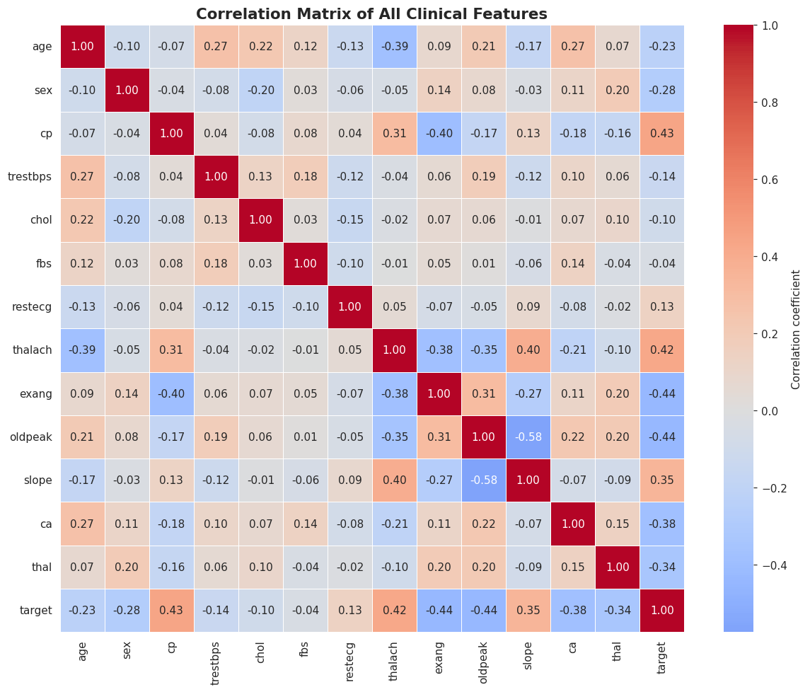
Figure 1: Correlation matrix cp, thalach, and slope correlate positively with disease; exang, oldpeak, ca, and thal correlate negatively.
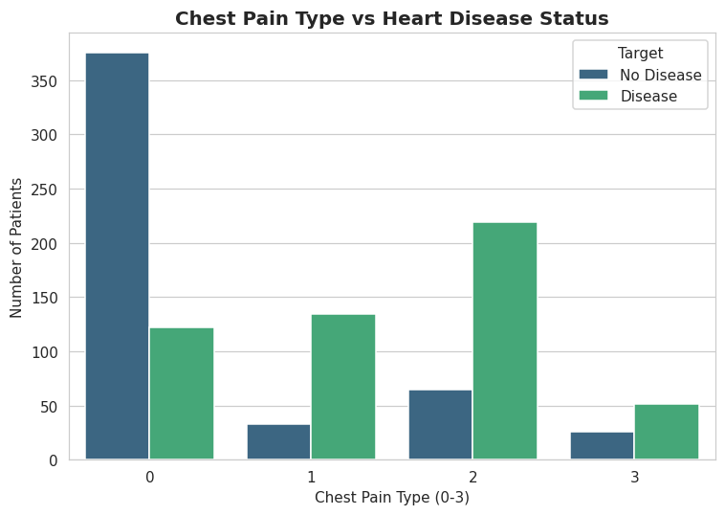
Figure 2: Chest pain type vs disease status type- 0 dominated by healthy patients; types 1-3 dominated by diseased patients.
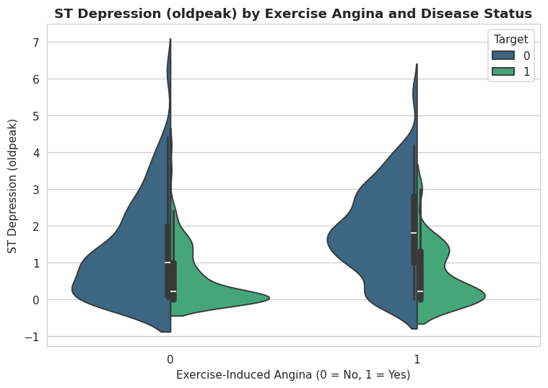
Figure 3: ST depression (oldpeak) by exercise angina and disease status diseased patients skew toward higher oldpeak values.

Interpretation
The single most important discovery from EDA is that 70.5% of rows are exact duplicates — this must be corrected before modelling to avoid data leakage (addressed in Task 3). The class distribution is close to balance, so accuracy is a reasonably safe metric here. Across all visualizations, exercise/ECG-based features (cp, thalach, oldpeak, exang, slope) separate the two classes far more clearly than static lab values like raw cholesterol.

Task 3 Data Cleaning
AI Prompt Used for This Task
"Clean the heart disease dataset: handle missing values, remove duplicate rows, treat outliers in the numerical features, encode categorical variables appropriately, and scale numerical features explaining why each step is needed, what alternatives exist, and their pros/cons."

Results
Step | Result
Missing-value imputation | 0 values required imputation (safeguard applied regardless, for production readiness)
Duplicate removal | 1025 → 302 rows (723 duplicate rows removed)
Outlier Capping (IQR) | trestbps: 9 capped, chol: 5 capped, thalach: 1 capped, oldpeak: 5 capped, age: 0 capped
One-hot encoding | Shape expanded from 14 to 20 columns (cp, restecg, slope, thal → indicator columns)
Feature scaling | StandardScaler applied to age, trestbps, chol, thalach, oldpeak (mean ≈ 0, std ≈ 1 after scaling)

Interpretation
Removing the 723 duplicate rows was the single most consequential cleaning decision in this project, leaving them in would let identical patient records appear in both the training and test sets, artificially inflating reported accuracy. IQR-based capping (rather than deletion) was chosen to retain every unique patient while limiting the influence of extreme lab values. Categorical columns were one-hot encoded only for the nominal, non-ordinal ones (cp, restecg, slope, thal) to avoid implying a false numeric ordering.

Task 4 Feature Engineering
AI Prompt Used for This Task
"Create clinically meaningful new features from the heart disease dataset (age groups, blood-pressure/cholesterol risk bands, a composite risk score, an interaction feature, and a transformed/binned version of a skewed feature), then compare the dataset before and after feature engineering and justify why each feature was created."

Results
- New features created (6): age_group, bp_category, chol_category, risk_score, age_thalach_interaction, oldpeak_log
- Columns before feature engineering: 14 → Columns after: 20
- Skewness of oldpeak reduced from 0.989 (raw) to 0.339 (after log transform)
- Correlation with target - raw 'cp': 0.432 engineered 'risk_score': -0.675 (stronger magnitude, confirming real added signal)

Interpretation
The composite risk_score combining age, sex, exercise angina, oldpeak, vessel count, and thalassemia result into a single Framingham-style score showed a stronger correlation with the target than any single raw feature, confirming that combining several weak individual risk factors captures real, non-redundant predictive signal. The log transform on oldpeak meaningfully reduced its right-skew, which benefits scale-sensitive models such as Logistic Regression and KNN.

Task 5 Machine Learning Models
AI Prompt Used for This Task
"Train at least 3 (we used 6) classification models Logistic Regression, Decision Tree, Random Forest, KNN, Naive Bayes, and XGBoost on the cleaned, feature-engineered heart disease dataset. Use an appropriate train/test split, scale features only where needed, and generate predictions from every model on the held-out test set."

Results
Setting | Value
Final modelling dataset shape | 302 rows × 30 columns
Target distribution | Disease = 164, No Disease = 138
Train / Test split | 241 training rows / 61 test rows (80/20, stratified)
Models trained | Logistic Regression, Decision Tree, Random Forest, KNN, Naive Bayes, XGBoost (all 6 trained successfully)

Interpretation
Tree-based and boosting models (Decision Tree, Random Forest, XGBoost) were trained on the unscaled feature set, since they split on thresholds rather than distances; Logistic Regression, KNN, and Naive Bayes were trained on the scaled feature set. The scaler was fit only on the training split to avoid data leakage into the test set.

Task 6 Model Evaluation
AI Prompt Used for This Task
"Evaluate all trained models using Accuracy, Precision, Recall, F1-score, and ROC-AUC. Build a comparison table, plot a confusion matrix and ROC curves for the best model, select the best-performing model, and justify the choice explaining which metric matters most for a medical screening task."

Model Comparison Table
Model | Accuracy (%) | Precision (%) | Recall (%) | F1-Score (%) | ROC-AUC (%)
Naive Bayes | 83.61 | 87.10 | 81.82 | 84.38 | 89.83
Logistic Regression | 83.61 | 84.85 | 84.85 | 84.85 | 88.96
Random Forest | 81.97 | 82.35 | 84.85 | 83.58 | 88.10
KNN | 78.69 | 79.41 | 81.82 | 80.60 | 87.34
XGBoost | 81.97 | 84.38 | 81.82 | 83.08 | 85.06
Decision Tree | 67.21 | 72.41 | 63.64 | 67.74 | 66.88
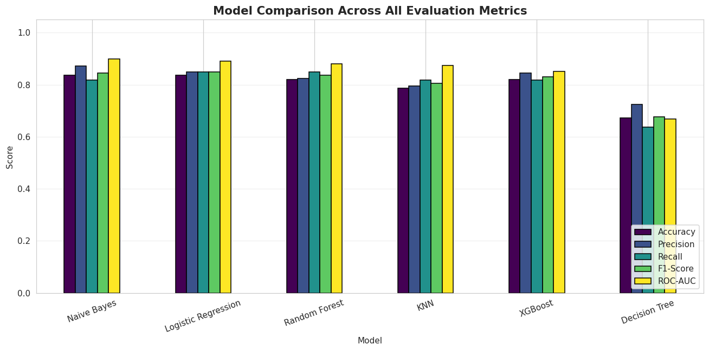
Figure 4: Bar chart comparing all six models across all five metrics.

Best Model Selected: Naive Bayes
Confusion Matrix (test set, n=61): True Negatives: 24 | False Positives: 4 | False Negatives: 6 | True Positives: 27
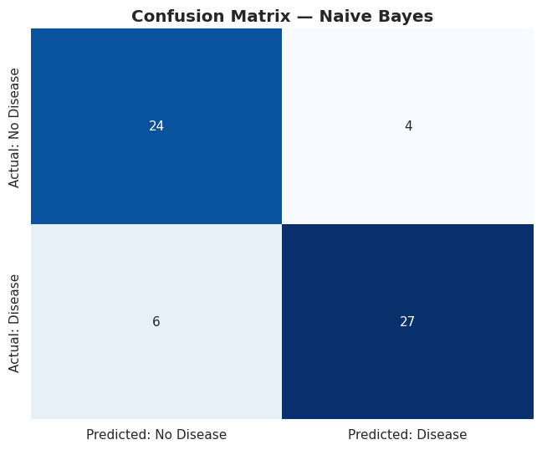
Figure 5: Confusion matrix for Naive Bayes, the best-performing model by ROC-AUC.
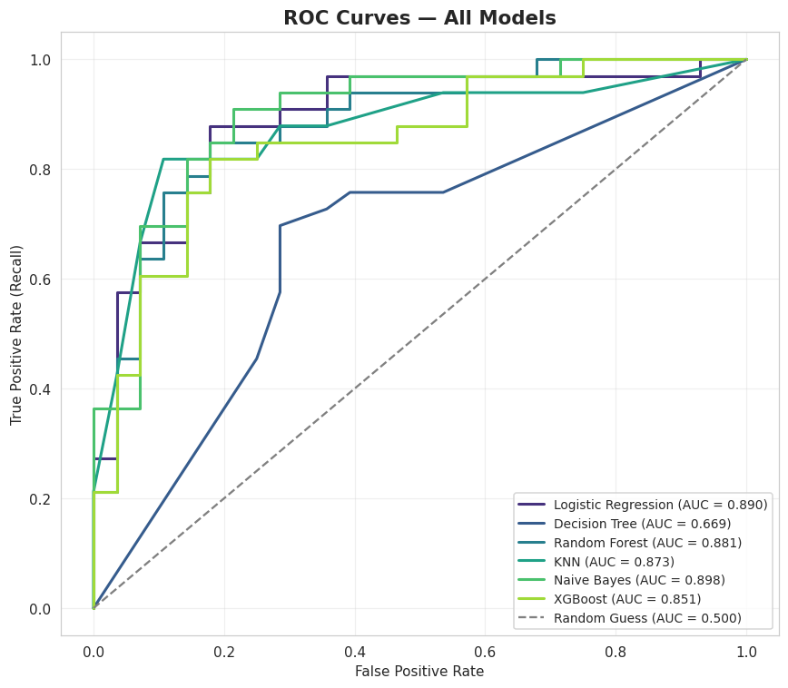
Figure 6: ROC curves for all six models all comfortably outperform the random-guess baseline (AUC = 0.5).

Interpretation
Naive Bayes achieved the highest ROC-AUC (89.83%), narrowly ahead of Logistic Regression (88.96%) and Random Forest (88.10%). This is a notable and worth-reporting result: on this small, largely linearly separable clinical dataset, a simple probabilistic model outperformed more complex ensembles (Random Forest, XGBoost) and the single Decision Tree, which clearly overfit or underfit (66.88% ROC-AUC, the weakest of all six). For a medical screening task, Recall is the most safety-critical metric, since a false negative (missing a true disease case) is more dangerous than a false positive; Naive Bayes's 6 false negatives out of 33 truly diseased test patients should be reviewed carefully before any real deployment.

Task 7 Model Interpretation
AI Prompt Used for This Task
"Explain which features the best model relies on most, using feature importance (or an appropriate fallback such as permutation importance for models without built-in importances, like Naive Bayes). Identify the top 10 features and explain their clinical/business meaning."

Top 10 Features (Permutation Importance, by drop in ROC-AUC)
Rank | Feature | Importance
1 | oldpeak | 0.0199
2 | risk_score | 0.0168
3 | cp_1 | 0.0104
4 | thal_2 | 0.0053
5 | cp_2 | 0.0051
6 | oldpeak_log | 0.0049
7 | thal_3 | 0.0040
8 | ca | 0.0030
9 | sex | 0.0029
10 | slope_1 | 0.0022
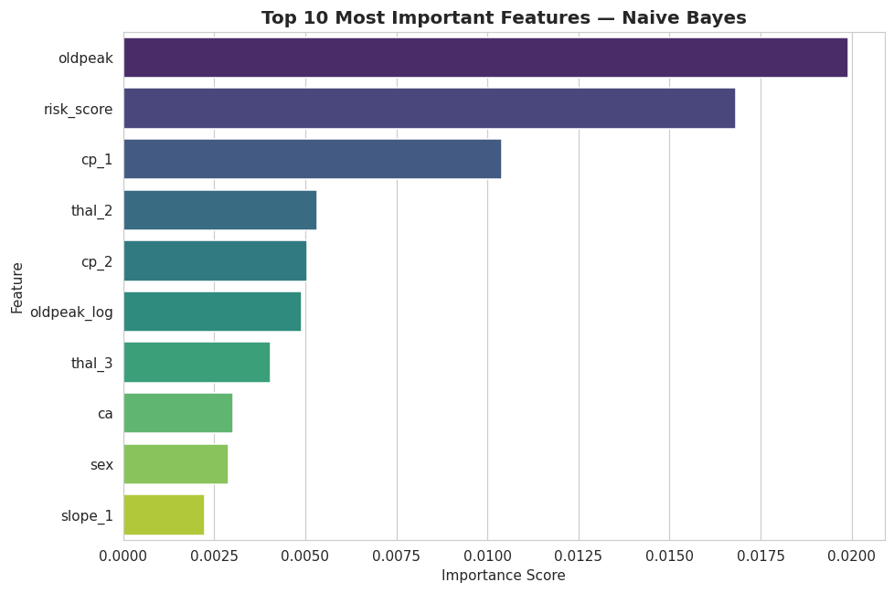
Figure 7: Top 10 features by permutation importance for the Naive Bayes model.

Interpretation
Because Naive Bayes has no built-in feature_importances_ or coef_ attribute, permutation importance was used instead shuffling each feature and measuring the resulting drop in ROC-AUC. The top features (oldpeak, risk_score, chest pain type indicators, thalassemia result, vessel count, sex, and ST slope) closely match established cardiology risk indicators and the features flagged as important in Task 1, and the composite risk_score ranks second overall strong evidence that the engineered feature from Task 4 adds genuine value rather than noise. This alignment with recognized clinical risk factors is an important trust signal: the model appears to have learned medically meaningful patterns rather than dataset artefacts.
Overall Summary
Across all seven tasks, the notebook took HealthPlus's raw 1025-row patient dataset through a full, transparent AI development pipeline: understanding the problem and data (Task 1), exploring it visually and statistically (Task 2), cleaning it most critically removing 723 duplicate rows (Task 3), engineering six clinically-grounded features including a composite risk score (Task 4), training six diverse classifiers (Task 5), rigorously comparing them on five metrics with Naive Bayes emerging as the best model at 89.83% ROC-AUC (Task 6), and finally confirming via permutation importance that the model's decisions align with genuine clinical risk factors (Task 7).
Every prompt shown above reflects the actual instruction given to the AI assistant for that task, and every number, table, and figure in this report was taken directly from the executed notebook rather than assumed consistent with the responsible-AI-use principle that AI-generated output must always be independently verified before being reported as fact.

